

Semester One Examination, 2020

Question/Answer booklet

MATHEMATICS

SOLUTIONS
METHODS
UNIT 3

Section Two:

Calculator-assumed

WA student number: In figures

In words

Your name

Number of additional
answer booklets used
(if applicable):

Time allowed for this section
Reading time before commencing work: ten minutes
Working time: one hundred minutes

Materials required/recommended for this section
To be provided by the supervisor
This Question/Answer booklet
Formula sheet (retained from Section One)

To be provided by the candidate
Standard items: pens (blue/black preferred), pencils (including coloured), sharpener,
correction fluid/tape, eraser, ruler, highlighters

Special items: drawing instruments, templates, notes on two unfolded sheets of A4 paper, and up to three calculators approved for use in this examination

Important note to candidates
No other items may be taken into the examination room. It is your responsibility to ensure that you do not have any unauthorised material. If you have any unauthorised material with you, hand it to the supervisor before reading any further.

Structure of this paper

Section | Number of  questions  available | Number of  questions to  be answered | Working  time  (minutes) | Marks  available | Percentage  of  examination
Section One:  Calculator-free | 8 | 8 | 50 | 52 | 35
Section Two:  Calculator-assumed | 13 | 13 | 100 | 98 | 65
 |  |  |  | Total | 100

Instructions to candidates

1. The rules for the conduct of examinations are detailed in the school handbook. Sitting this examination implies that you agree to abide by these rules.

2. Write your answers in this Question/Answer booklet preferably using a blue/black pen.
Do not use erasable or gel pens.

3. You must be careful to confine your answers to the specific question asked and to follow any instructions that are specific to a particular question.

4. Show all your working clearly. Your working should be in sufficient detail to allow your answers to be checked readily and for marks to be awarded for reasoning. Incorrect answers given without supporting reasoning cannot be allocated any marks. For any question or part question worth more than two marks, valid working or justification is required to receive full marks. If you repeat any question, ensure that you cancel the answer you do not wish to have marked.

5. It is recommended that you do not use pencil, except in diagrams.

6. Supplementary pages for planning/continuing your answers to questions are provided at the end of this Question/Answer booklet. If you use these pages to continue an answer, indicate at the original answer where the answer is continued, i.e. give the page number.

7. The Formula sheet is not to be handed in with your Question/Answer booklet.
Section Two: Calculator-assumed 65% (98 Marks)
This section has thirteen questions. Answer all questions. Write your answers in the spaces provided.

Working time: 100 minutes.

Question 9 (6 marks)
A seafood processor buys batches of $n$ prawns from their supplier, where $n$ is a constant. In any given batch, the probability that a prawn is export quality is $p$, where $p$ is a constant and the quality of an individual prawn is independent of other prawns.

The discrete random variable $X$ is the number of export quality prawns in a batch and the mean of $X$ is $79.2$ and standard deviation of $X$ is $6.6$.

(a) State the name given to the distribution of $X$ and determine its parameters $n$ and $p$.
(4 marks)
Solution
$X$ follows a binomial distribution.

$$np=79.2 \\ np\left(1-p\right)={6.6}^{2}$$

$$n=176, p=\frac{9}{20}=0.45$$

Specific behaviours
names binomial distribution
ü equation for mean and variance (or sd)
ü value of $n$
ü value of $p$

(b) Determine the probability that more than 50% of prawns in a randomly selected batch are export quality. (2 marks)
Solution
$$50\%×176=88$$

$$P\left(X≥89\right)=0.0797$$

Specific behaviours
lower bound
ü probability

Question 10 (8 marks)
The voltage, $V$ volts, supplied by a battery $t$ hours after timing began is given by

$$V=8.95e^{-0.265t}$$

(a) Determine
Solution
$$V\left(0\right)=8.95 \text{V}$$
Specific behaviours
correct value

(i) the initial voltage. (1 mark)

Solution
$$V\left(3\right)=4.04 \text{V}$$
Specific behaviours
correct value

(ii) the voltage after $3$ hours. (1 mark)

(iii) the time taken for the voltage to reach $0.03$ volts. (1 mark)
Solution
$$t=21.5 \text{h}$$
Specific behaviours
correct value

(b) Show that $\begin{matrix}dV \\ \overline{dt}\end{matrix}=aV$ and state the value of the constant $a$. (2 marks)
Solution
$$\frac{dV}{dt}=-0.265\left(8.95e^{-0.265}\right) \\ =aV$$

$$a=-0.265$$
Specific behaviours
correct derivative
ü value of $a$

(c) Determine the rate of change of voltage $3$ hours after timing began. (1 mark)
Solution
$$\dot{V}=-0.265×4.04=-1.07 \text{V/h}$$
Specific behaviours
correct rate

(d) Determine the time at which the voltage is decreasing at $5\%$ of its initial rate of decrease.
(2 marks)
Solution
$$\dot{V}∝V⇒e^{-0.265t}=0.05$$

$$t=11.3 \text{h}$$

Specific behaviours
indicates suitable method
ü correct time

Question 11 (8 marks)
A small body moving in a straight line has displacement $x$ cm from the origin at time $t$ seconds given by
$$x=5\cos\left(2t-1\right)+6.5, 0≤t≤3.$$

(a) Use derivatives to justify that the maximum displacement of the body occurs when $t=0.5$.
(4 marks)
Solution
$$\frac{dx}{dt}=-10\sin\left(2t-1\right) \\ t=0.5⇒\frac{dx}{dt}=-10\sin\left(0\right)=0$$
Hence when $t=0.5, x$ has a stationary point.

$$\frac{d^{2}x}{dt^{2}}=-20\cos\left(2t-1\right) \\ t=0.5⇒\frac{d^{2}x}{dt^{2}}=-20\cos\left(0\right)=-20$$
Since second derivative is negative, the stationary point is a maximum, and so the body has a maximum displacement when $t=0.5$.

Specific behaviours
first derivative
ü indicates stationary point at required time
ü value of second derivative at required time
ü statement that justifies maximum

(b) Determine the time(s) when the velocity of the body is not changing. (2 marks)
Solution
$$a=\frac{d^{2}x}{dt^{2}}=-20\cos\left(2t-1\right)$$
$$a=0⇒\cos\left(2t-1\right)=0$$

$$t=\frac{π}{4}+\frac{1}{2}, \frac{3π}{4}+\frac{1}{2}≈1.285, 2.856 \text{seconds}$$

Specific behaviours
indicates acceleration/second derivative must be zero
ü states exact (or approximate) times in interval

(c) Express the acceleration of the body in terms of its displacement $x$. (2 marks)
Solution
$$a=-20\cos\left(2t-1\right) \\ =-4\left(5\cos\left(2t-1\right)\right) \\ =-4\left(x-6.5\right)$$

Specific behaviours
factors out $-4$
ü correct expression

Question 12 (7 marks)
The function $f$ is defined as $f\left(x\right)=\begin{matrix}5e^{0.125x} \\ \overline{ x }\end{matrix} , x>0$, and the graph of $y=f(x)$ is shown below.
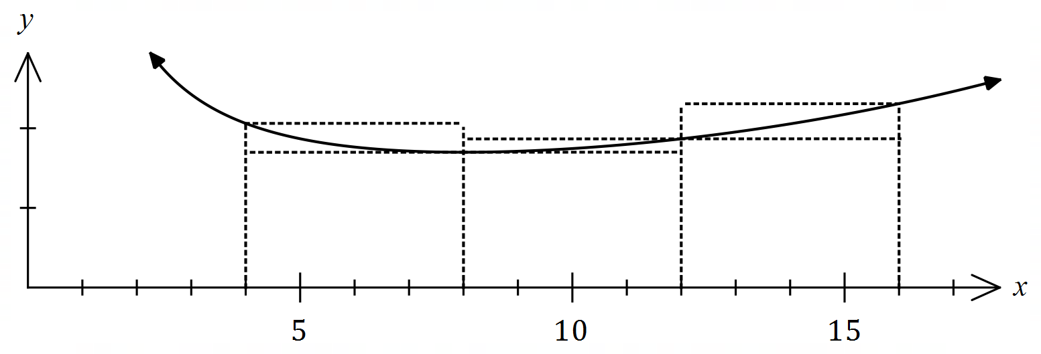
(a) Complete the missing values in the table below, rounding to $2$ decimal places. (1 mark)
Solution
See table
Specific behaviours
both correct

$$x$$ | $$4$$ | $$8$$ | $$12$$ | $$16$$
$$f(x)$$ | $$2.06$$ | $$1.70$$ | $$1.87$$ | $$2.31$$

(b) Use the areas of the rectangles shown on the graph to determine an under- and over-estimate for $\int_{4}^{16}{\underset{ }{\overset{ }{f(x)}}}dx$. (3 marks)
Solution
$$U=4\left(1.70+1.70+1.87\right)=4×5.27=21.08$$

$$O=4\left(2.06+1.87+2.31\right)=4×6.24=24.96$$

Specific behaviours
indicates $δx=4$
ü under-estimate
ü over-estimate

(c) Use your answers to part (b) to obtain an estimate for $\int_{4}^{16}{\underset{ }{\overset{ }{f(x)}}}dx$. (1 mark)
Solution
$$E=\left(21.08+24.96\right)÷2≈23.0$$

Specific behaviours
correct mean

(d) State whether your estimate in part (c) is too large or too small and suggest a modification to the numerical method employed to obtain a more accurate estimate. (2 marks)
Solution
Estimate is too large ($f(x)$ is concave upwards).

Better estimate can be found using a larger number of thinner rectangles.

Specific behaviours
states too big
ü indicates modification to improve estimate

Question 13 (8 marks)
A bag contains four similar balls, one coloured red and three coloured green. A game consists of selecting two balls at random, one after the other and with the first replaced before the second is drawn. The random variable $X$ is the number of red balls selected in one game.

(a) Complete the probability distribution for $X$ below. (3 marks)

$$x$$ | $$0$$ | $$1$$ | $$2$$
$$P(X=x)$$ | $$\frac{9}{16}$$ | $$\frac{6}{16}$$ | $$\frac{1}{16}$$
Solution
$$P\left(X=0\right)={\left(\frac{3}{4}\right)}^{2}=\frac{9}{16}; P\left(X=2\right)={\left(\frac{1}{4}\right)}^{2}=\frac{1}{16}; P\left(X=1\right)=1-\frac{9+1}{16}=\frac{6}{16}$$

$$(0.5625, 0.375, 0.0625)$$
Specific behaviours
one correct probability
ü probabilities have sum of $1$
✓ all correct probabilities

(b) Determine $E(X)$ and $\operatorname{Var}{(X)}$. (2 marks)
Solution
$$E\left(X\right)=0+\frac{6}{16}+\frac{2}{16}=\frac{1}{2}; \operatorname{Var}\left(X\right)=\frac{3}{8}=0.375$$

NB Using CAS, $sd=\frac{\sqrt{6}}{4}≈0.6124$.

Specific behaviours
expected value
✓ variance

(c) A player wins a game if the two balls selected have the same colour. Determine the probability that a player wins no more than three times when they play five games.
(3 marks)
Solution
$$Y\sim B\left(5,\frac{10}{16}\right)$$

$$P\left(Y≤3\right)≈0.6185$$

Specific behaviours
defines distribution
ü states probability required
ü correct probability

Question 14 (8 marks)
A curve has equation $y=\left(x-3\right)e^{2x}$.

(a) Show that the curve has only one stationary point and use an algebraic method to determine its nature. (3 marks)
Solution
$$y^{'}=2xe^{2x}-5e^{2x} \\ =e^{2x}\left(2x-5\right)$$
For stationary point, require $y^{'}=0$ and since $e^{2x}≠0$ then $x=2.5$ - there is only one stationary point.

$$y^{''}=4xe^{2x}-8e^{2x}$$
$$x=2.5⇒y^{''}=2e^{5}$$
Hence stationary point is a local minimum.

Specific behaviours
first derivative
ü uses factored form to justify one stationary point
ü indicates minimum using derivatives (sign or 2nd)

(b) Justify that the curve has a point of inflection when $x=2$. (3 marks)
Alternative Solution
$$y^{''}=4e^{2x}\left(x-2\right) \\ y^{''}(2)=4e^{2(2)}\left(2-2\right)=0$$
$$y^{'''}=4e^{2x}\left(2x-3\right) \\ y'''\left(2\right)=4e^{4}$$

Hence point of inflection as $f^{''}\left(2\right)=0$ and $f^{'''}\left(2\right)≠0$.

Specific behaviours
shows second derivative is zero
ü calculates third derivative
ü explains justification

Solution
$$y^{''}=4e^{2x}\left(x-2\right) \\ y^{''}\left(1.9\right)=4e^{2\left(1.9\right)}\left(1.9-2\right)≈-18 \\ y^{''}(2)=4e^{2(2)}\left(2-2\right)=0 \\ y^{''}\left(2.1\right)=4e^{2\left(2.1\right)}\left(2.1-2\right)≈27$$

Hence point of inflection as concavity changes from $-$ve to $+$ve as $x$ increases through $x=2$.

Specific behaviours
shows second derivative is zero
ü calculates second derivative either side
ü explains justification

(c) Sketch the curve on the axes below. (2 marks)

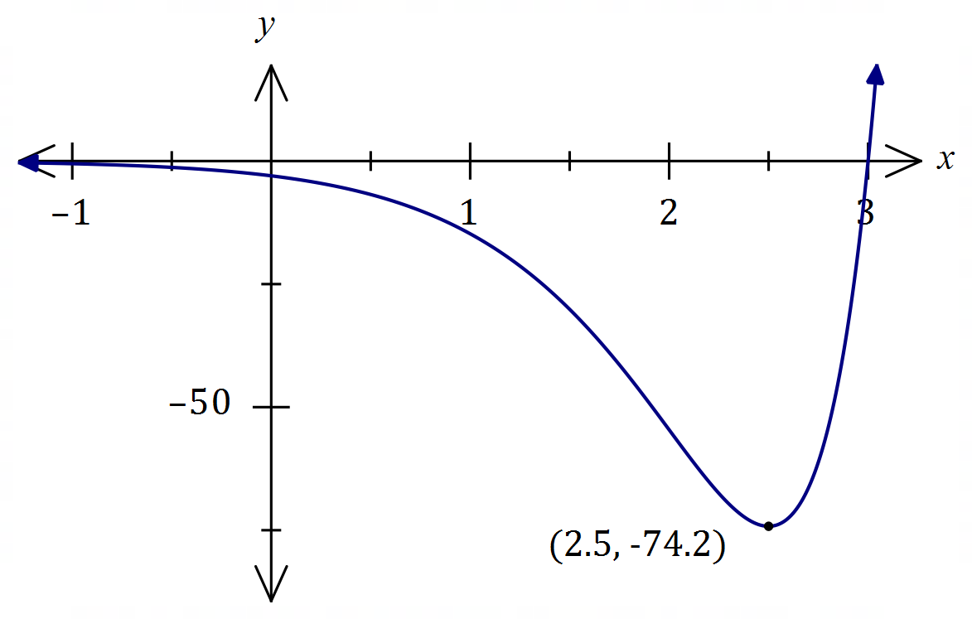
Solution
See graph
Specific behaviours
minimum, $y$-intercept
ü correct shape

Question 15 (9 marks)
A small body leaves point $A$ and travels in a straight line for $23$ seconds until it reaches point $B$.
The velocity $v$ m/s of the body is shown in the graph below for $0≤t≤23$ seconds.

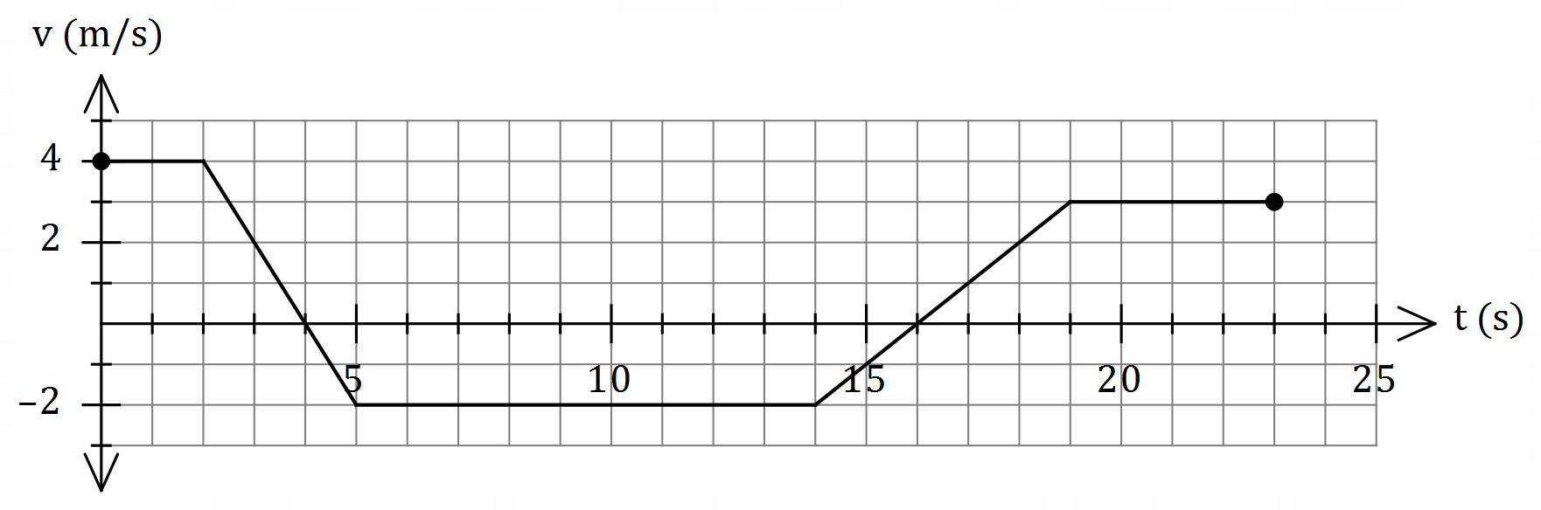

(a) Use the graph to evaluate $\int_{0}^{4}{\underset{ }{\overset{ }{v}}}dt$ and interpret your answer with reference to the motion of the small body. (3 marks)
Solution
$$\int_{0}^{4}{v}dt=2×4+\frac{1}{2}×2×4=12 \text{m}$$

The change in displacement of the body during the first $4$ seconds is $12$ m.
OR
The body has moved $12$ m to the right of $P$ during first $4$ seconds.

Specific behaviours
value of integral
ü interprets as change in displacement
ü includes specific time and distance with units in interpretation

(b) Determine an expression, in terms of $t$, for the displacement of the body relative to $A$ during the interval $2≤t≤5$. (3 marks)
Solution
$$v=8-2t⇒x=\int{8-2t}dt=8t-t^{2}+c$$

$$t=2,x=8⇒8=8\left(2\right)-2^{2}+c⇒c=-4$$

$$x=8t-t^{2}-4, 2≤t≤5$$

Specific behaviours
expression for $v$
ü expression for $x$ with constant $c$
ü correct expression for $x$

(c) Determine the time(s) at which the body was at point $A$ for $0<t≤23$. (3 marks)
Solution
$$x\left(5\right)=12+\frac{1}{2}×1×\left(-2\right)=11$$
$$11-2\left(t-5\right)=0⇒t=10.5$$

$$x\left(19\right)=-4.5$$
$$-4.5+3\left(t-19\right)=0⇒t=20.5$$

Body at point $A$ when $t=10.5$ s and $t=20.5$ s.

Specific behaviours
indicates appropriate method using areas
ü one correct time
ü two correct times

Question 16 (9 marks)
When a machine is serviced, between $1$ and $5$ of its parts are replaced. Records indicate that $7\%$ of machines need $1$ part replaced, $8\%$ need $5$ parts replaced, $12\%$ need $4$ parts replaced, and the mean number of parts replaced per service is $2.82$.

Let the random variable $X$ be the number of parts that need replacing when a randomly selected machine is serviced.

(a) Complete the probability distribution table for $X$ below. (4 marks)

$$x$$ | $$1$$ | $$2$$ | $$3$$ | $$4$$ | $$5$$
$$P(X=x)$$ | $$0.07$$ | $$0.32$$ | $$0.41$$ | $$0.12$$ | $$0.08$$

Solution
Let $P\left(x=2\right)=a, P\left(X=3\right)=b$ then

$$0.27+a+b=1 \\ 0.07+2a+3b+0.48+0.4=2.82$$
Hence
$$a=0.32, b=0.41$$

Specific behaviours
values for $x=1, 4, 5$
ü equation using sum of probabilities
ü equation using expected value
ü values for $x=2, 3$

Solution
Using CAS, $σ=1.00379281$

Hence $Var\left(X\right)=σ^{2}=1.0076$

Specific behaviours
indicates sd using CAS
ü correct variance

(b) Determine $Var⁡(X)$. (2 marks)

The cost of servicing a machine is $\$56$ plus $\$12.50$ per part replaced and the random variable $Y$ is the cost of servicing a randomly selected machine.

(c) Determine the mean and standard deviation of $Y$. (3 marks)
Solution
$$Y=56+12.5X$$

$$E\left(Y\right)=56+12.5×2.82=\$91.25$$

$$σ_{Y}=12.5×1.00379≈\$12.55$$

Specific behaviours
equation relating $X$ and $Y$
ü mean
ü standard deviation (penalty no units: $-1$ mark)

Question 17 (6 marks)
Some values of the polynomial function $f$ are shown in the table below:

$$x$$ | $$-2$$ | $$-1$$ | $$0$$ | $$1$$ | $$2$$ | $$3$$ | $$4$$
$$f(x)$$ | $$-8$$ | $$0$$ | $$5$$ | $$6$$ | $$4$$ | $$1$$ | $$-3$$

(a) Evaluate $\int_{1}^{4}{\underset{ }{\overset{ }{f'(x)}}}dx$. (2 marks)
Solution
$$\int_{1}^{4}{f^{'}\left(x\right)}dx=f\left(4\right)-f\left(1\right) \\ =-3-6 \\ =-9$$

Specific behaviours
uses fundamental theorem
ü correct value

The following is also known about $f'(x)$:

Interval | $$-2≤x≤1$$ | $$x=1$$ | $$1≤x≤4$$
$$f'(x)$$ | $$f^{'}\left(x\right)>0$$ | $$f^{'}\left(x\right)=0$$ | $$f^{'}\left(x\right)<0$$

(b) Determine the area between the curve $y=f'(x)$ and the $x$-axis, bounded by $x=-2$ and $x=3$. (4 marks)
Solution
Area to left of $x=1$ is above axis but to left is below so will need to negate/drop negative sign for that integral:

$$\text{Area}=\int_{-2}^{1}{f^{'}\left(x\right)}dx-\int_{1}^{3}{f^{'}\left(x\right)}dx \\ =f\left(1\right)-f\left(-2\right)-\left[f\left(3\right)-f\left(1\right)\right] \\ =2f\left(1\right)-f\left(-2\right)-f\left(3\right) \\ =2\left(6\right)-\left(-8\right)-1 \\ =19 \text{sq units}$$

Specific behaviours
ü integral for $f^{'}\left(x\right)>0$
ü negated integral for $f^{'}\left(x\right)<0$
ü uses fundamental theorem
ü correct area

Question 18 (8 marks)
Let $P(a, b)$ be a point in the first quadrant that
lies on the curve $y=8-x^{2}$ and $A$ be the area
of the triangle formed by the tangent to the
curve at $P$ and the coordinate axes.

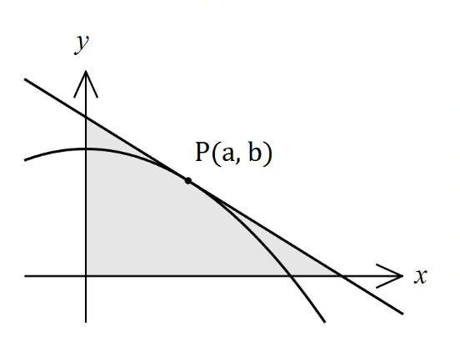

(a) Show that $A=\begin{matrix}{\left(a^{2}+8\right)}^{2} \\ \overline{ 4a }\end{matrix}$. (4 marks)
Solution
Gradient at $P$:
$$\frac{dy}{dx}=-2x⇒m_{P}=-2a$$
Equation of tangent:
$$y-b=-2a(x-a) \\ y-\left(8-a^{2}\right)=-2ax+2a^{2} \\ y=-2ax+a^{2}+8$$
Axes intercepts:
$$y=0⇒x=\frac{a^{2}+8}{2a}, x=0⇒y=a^{2}+8$$
Area:
$$A=\frac{1}{2}\left(\frac{a^{2}+8}{2a}\right)\left(a^{2}+8\right)=\frac{{\left(a^{2}+8\right)}^{2}}{4a}$$

Specific behaviours
$b$ in terms of $a$ and $m_{P}$
ü equation of tangent in terms of $a, x, y$ (any form)
ü axes intercepts
ü indicates area of right triangle

(b) Use calculus to determine the coordinates of $P$ that minimise $A$. (4 marks)
Solution
$$\frac{dA}{da}=\frac{3a^{4}+16a^{2}-64}{4a^{2}}$$
$$\frac{dA}{da}=0⇒a=\frac{2\sqrt{6}}{3}≈1.633$$

$$\frac{d^{2}A}{da^{2}}={\left.\frac{3a^{4}+64}{2a^{3}}\right|}_{a=\frac{2\sqrt{6}}{3}}=4\sqrt{6}⇒\text{Minimum}$$
$$b=8-a^{2}=\frac{16}{3}$$
Hence $P\left(\frac{2\sqrt{6}}{3},\frac{16}{3}\right)≈P(1.633, 5.333)$

Specific behaviours
first derivative
ü solves for $a$
ü indicates check for minimum (graph, sign or second derivative test)
ü correct coordinates, exact or at least $2$ dp

Question 19 (7 marks)
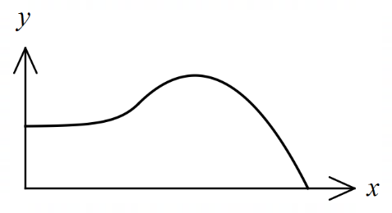
The edges of a swimming pool design, when viewed
from above, are the $x$-axis, the $y$-axis and the curves

$y=-0.2x^{2}+3x-6.25$ and $y=2.75+e^{x-5}$

where $x$ and $y$ are measured in metres.

(a) Determine the gradient of the curve at the point where the two curves meet. (2 marks)
Solution
Curves intersect when $x=5$

$$y^{'}=-0.4\left(5\right)+3=e^{5-5}=1$$

Specific behaviours
$x$-coordinate of intersection
ü common gradient

(b) Determine the surface area of the swimming pool. (4 marks)
Solution
$$A_{1}=\int_{0}^{5}{2.75+e^{x-5}}dx=\frac{59}{4}-\frac{1}{e^{5}}≈14.743$$

$$A_{2}=\int_{5}^{12.5}{-0.2x^{2}+3x-6.25}dx=\frac{225}{8}≈28.125$$

$$A_{1}+A_{2}=\frac{343}{8}-\frac{1}{e^{5}}≈42.868 {\text{m}}^{2}$$

Specific behaviours
upper bound for parabola
ü area $A_{1}$
ü area $A_{2}$
ü total area, with units

(c) Given that the water in the pool has a uniform depth of $135$ cm, determine the capacity of the pool in kilolitres ($1$ kilolitre of water occupies a volume of $1$ m³). (1 mark)
Solution
$$C=42.868×1.35≈57.87 \text{kL}$$

Specific behaviours
correct capacity

Question 20 (6 marks)
Given that $f\left(2\right)=-3, f^{'}\left(2\right)=4, g\left(2\right)=2$ and $g^{'}\left(2\right)=5$, evaluate $h'(2)$ in each of the following cases:

(a) $h\left(x\right)=f\left(x\right)⋅g(x)$. (2 marks)

Solution
$$h^{'}\left(2\right)=f^{'}\left(2\right)×g\left(2\right)+f\left(2\right)×g^{'}\left(2\right) \\ =4×2+(-3)×5 \\ =-7$$

Specific behaviours
uses product rule
ü correct value

(b) $h\left(x\right)={\left(g\left(x\right)\right)}^{4}$. (2 marks)
Solution
$$h^{'}\left(2\right)=4×{\left(g\left(2\right)\right)}^{3}×g'(2) \\ =4×2^{3}×5 \\ =160$$

Specific behaviours
uses chain rule
ü correct value

(c) $h\left(x\right)=f\left(g\left(x\right)\right)$. (2 marks)
Solution
$$h^{'}\left(2\right)=f^{'}\left(g\left(2\right)\right)×g^{'}\left(2\right) \\ =f^{'}\left(2\right)×g^{'}\left(2\right) \\ =4×5 \\ =20$$

Specific behaviours
uses chain rule
ü correct value

Question 21 (8 marks)
When a byte of data is sent through a network in binary form (a sequence of bits - $0$'s and $1$'s), there is a chance of bit errors that corrupt the byte, i.e. a $0$ becomes a $1$ and vice versa.

Suppose a byte consists of a sequence of $8$bits and for a particular network, the chance of a bit error is $0.300\%.$

(a) Determine the probability that a byte is transmitted without corruption, rounding your answer to $5$ decimal places. (3 marks)
Solution
$$X\sim B(8, 0.003)$$

$$P\left(X=0\right)=0.97625$$

Specific behaviours
indicates binomial distribution
ü indicates probability to calculate
ü correct probability, to $5$ dp

(b) Determine the probability that during the transmission of $32$ bytes, at least one of the bytes becomes corrupted. (2 marks)
Solution
$$Y\sim B\left(32, 0.02375\right)$$

$$P\left(Y≥1\right)=0.5366$$

Specific behaviours
indicates correct method
ü correct probability

A Hamming code converts a byte of $8$ bits into a byte of $12$ bits for transmission, with the advantage that if just one bit error occurs during transmission, it can be detected and corrected.

(c) Determine the probability that during the transmission of $32$ bytes using Hamming codes, at least one of the bytes becomes permanently corrupted. (3 marks)
Solution
$$H\sim B\left(12, 0.003\right)$$

$$P\left(H≥2\right)=0.00058$$

$$M\sim B\left(32, 0.00058\right)⇒P\left(M≥1\right)=0.0185$$

Specific behaviours
ü states distribution of failures of a $12$ bit byte
probability that single Hamming code byte corrupted
ü correct probability

Supplementary page

Question number: _________

© 2020 WA Exam Papers. Kennedy Baptist College has a non-exclusive licence to copy and communicate this document for non-commercial, educational use within the school. No other copying, communication or use is permitted without the express written permission of WA Exam Papers. SN245-155-4.

